-4-

**Bossler Christian Preschool  
Info at Your Fingertips  
2024-2025**

If you need more information about the school’s goals, discipline, common childhood diseases, and communication with parents, parent volunteers, or anything not covered in this shortened version of the handbook, please ask.

**TIME SCHOOL IS IN SESSION** – Delays & Cancellations

* Classes are held on Tuesday & Thursday for 3-yr olds.
* Classes are held on Tuesday, Wednesday, & Thursday for 4/5 yr. olds.

**Morning** class starts at 9:15 am and ends at **11:30** am

* If there is a two-hour weather delay (by E-town school district) we will start at 10:00 am and end at 12:00 pm.
* When E-town school district cancels, BCP will also be cancelled. If the roads are deemed treacherous by the staff, we will cancel school.

**No child is to be brought into the classroom before 9:15 am**, nor picked up more than 5 minutes after class is over. If a child is repeatedly left beyond those limits with no prior arrangement, a babysitting fee will be assessed when the child is picked up. The fee is **$5.00** for every **10** **minutes** beyond pickup time. Continual late pickups could result in having your child removed from the program. If you are running late due to traffic, car problems, etc. please call or text us at 717-537-8192.

-1-

**Absence/Illness**

If your child will be absent from school for any reason, we ask that you notify the school by **calling or texting** 717-537-8192. If your child has a communicable disease, we ask that you notify the school so that other parents can be informed and may monitor their child for symptoms.

No child arriving at preschool noticeably ill, with a rash or a fever, will be admitted for the day. If a child becomes ill during class, the parent will be notified immediately.

Missed class time cannot be made up. Tuition cannot be refunded. Children must be symptom free without medication for 24 hours before returning to class.

If a medical emergency arises, the staff will administer first-aid. The parent or authorized adult will be notified as soon as possible. If medical attention is required, the staff will call 911.

**What Not To Bring To School**

Children should not bring toys to school. Show and tell is an exception. When we start show and tell a letter will be sent home with show and tell instructions.

**Birthday Treats**

Children enjoy celebrating birthdays. You will have a chance to sign up for your child’s birthday treat. If your child’s birthday is in the summer, you may pick another time to bring in a treat. Consider snacks like Go-Gurt, cheese sticks, or fruit cups. Make sure the treat is the same – all strawberry or blueberry. Please make arrangements ahead of your child’s birthday. NO fruit snacks.

-2-

**Tuition Rates**

The registration fee is $30. This is non-refundable unless we are unable to place your child in a class. Tuition for the year for two days per week is $945/year or $105 per month for 9 months. Tuition for three days per week is $1,170/year or $130 per month for 9 months. Tuition should be paid the last class day of the current month. See due dates on the calendar page. Payments not made on time will incur a late payment fee of $5. Cash payments must be in an envelope with your child’s name. Do not hand loose cash to a staff member. If a financial problem arises, please let us know so we can work out other payment arrangements.

**Withdrawal**

If you need to withdraw your child from preschool, we ask that you give a two-week notice. If we do not receive notice, you will forfeit any remaining paid tuition.

**Library Books**

Children are welcome to borrow books from our library. Your child may only take 1 book at a time. When the book is returned another book may be checked out. If you do not want your child to check out books, please send in a note. Please take care of our books. Keep them away from younger siblings and animals. If a book is lost or damaged beyond repair, a small fee of $3.00 will need to be paid before your child can take out any more books. Thank you for your understanding. If books are continually returned in bad shape, we may take away their checkout privileges.

-3-

Tuition Due Dates

Late tuition will be result in a $5.00 fee.

Sept. 5 Tuition is due

Sept. 26 Tuition is due

Oct. 31 Tuition is due

Nov. 21 Tuition is due

Dec. 19 Tuition is due

Jan. 30 Tuition is due

Feb. 27 Tuition is due

March 27 Tuition is due

April 24 Tuition is due

**Class Dojo**

Class Dojo is our means of communication. We will

have the “Today we…” paper posted, other important information, sign-ups, schedule, monthly newsletter,

and photos. Each family is expected to sign up for

class dojo. It will keep you up to date on school happenings like delays, cancellations, etc. A paper about Class Dojo was sent home at orientation.

**Calendar at a Glance 2024-2025**

**Subject to Change**

Sept. 5 1st day of school

Sept. 26 Tuition is due

Oct. 8 Vision Screening

Oct. 24 Fall Activities – Volunteers needed

Oct. 31 Tuition is due

Nov. 21 Thanksgiving Feast – Volunteers needed

Nov. 21 Tuition is due

Nov. 26-28 **NO SCHOOL**

Dec. 10 Gifts due for Hope Within

Dec. 12 Christmas celebration – Volunteers needed

Dec. 19 Christmas program – 10:15 am

Dec. 19 Tuition is due

Dec. 24- Jan. 2 **NO SCHOOL**

Jan. 7, 2025 School resumes

Jan. 21 **NO SCHOOL**

Jan. 30 Tuition is due

Feb. 13 Friendship party – Volunteers needed

Feb. 27 Tuition is due

March 4 **NO SCHOOL - CONFERENCES**

March 18 **NO SCHOOL**

March 27 Tuition is due

April 10 Easter Celebration- Volunteers needed

April 16-17 **NO SCHOOL- SPRING BREAK**

April 24 Tuition is due

April 29-30 Our Town – Volunteers needed

May 1 Our Town – Volunteers needed

May 8 Last Day – Closing program - children dropped off at school 9:45. Program at 10:00.

Picnic at the park – Volunteers needed

-5-

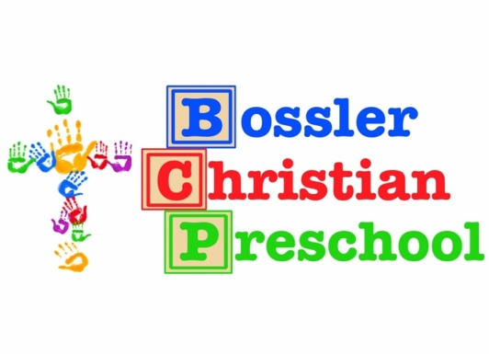

Parent Handbook

2024-2025

717-537-8192

Please keep this in a

convenient place so you may refer to

it when you have questions!

Thank you!